MINI PROJECT ON AWS
BIKEZONE – AWS DEPLOYMENT
First, I created two AWS EC2 servers. I used one server for the frontend and the other server for the backend. I created a key pair and downloaded the .pem file to connect to the servers securely.
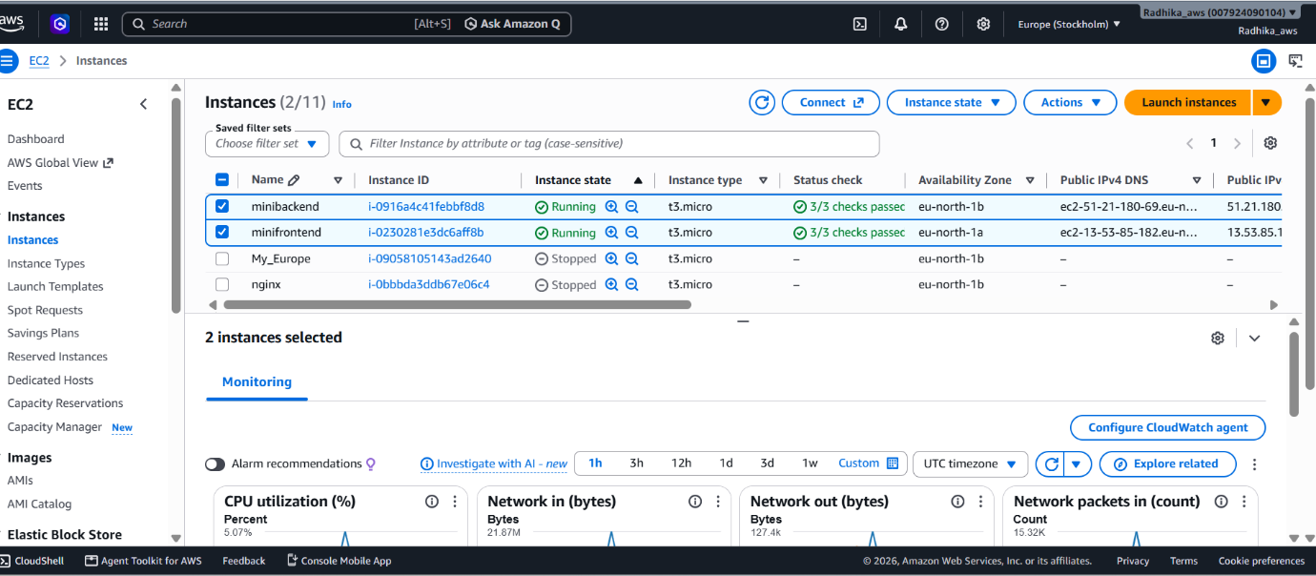
Frontend and backend server

Frontend Deployment
Next, I connected to the frontend EC2 server using the .pem file.
chmod 400 keypair .pem
ssh -i keypair.pem ubuntu@FRONTEND_IP
After connecting, I installed Nginx using:
sudo apt update
sudo apt install nginx -y
Then, I copied my frontend code to the Nginx folder and started the Nginx service:
sudo systemctl start nginx
Finally, I opened the frontend server's public IP address in the browser and checked that my BikeZone website was working successfully.
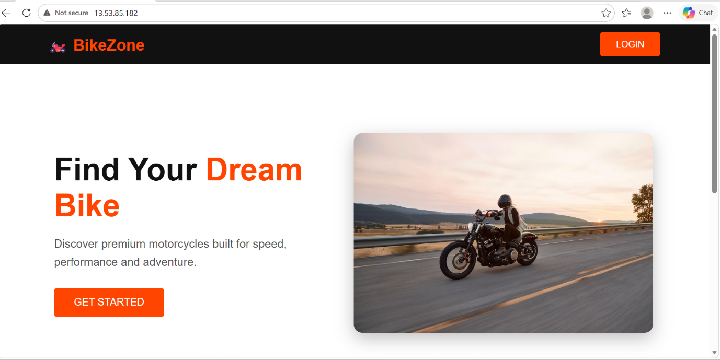
Frontend page
Backend Deployment
Next, I connected to the backend EC2 server using the .pem file.
I placed my backend code inside the app.py file using the sudo nano app.py command. The backend code contains the API that receives the customer details from my frontend and sends a response back.
After adding the code, I saved the file. The backend was then ready to connect with my frontend application.
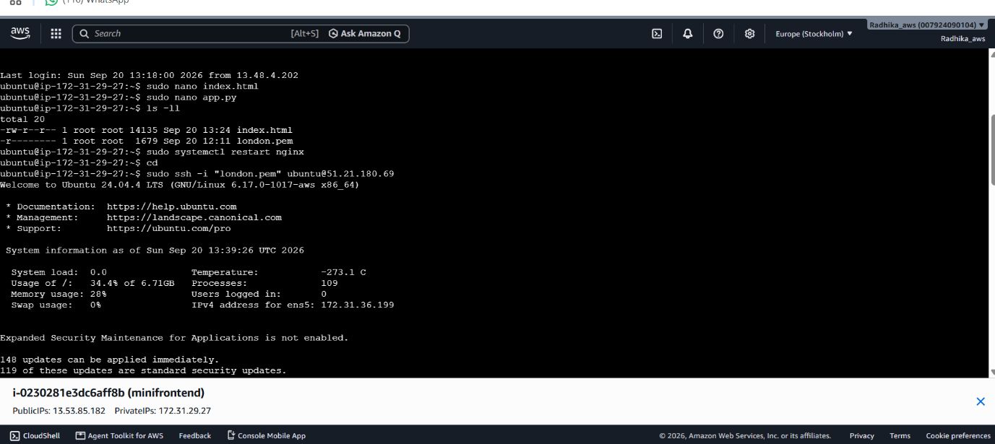
Sudo nano app.py

Connecting and Running the Project
After creating the backend, I copied the backend public IP address and added it to the fetch() function in my frontend code.
Fetch line: fetch("http://BACKEND_IP:5000/api/login").
This connects my frontend with the Flask backend. When I submit the customer details, the frontend sends the information to the backend through this API.
Next, I installed Python and the required packages on my backend EC2 server. These packages were needed to run my Flask backend application.
sudo apt install python3 python3-pip -y pip3 install flask flask-cors
After installing the packages, my backend server was ready to run the Flask application.
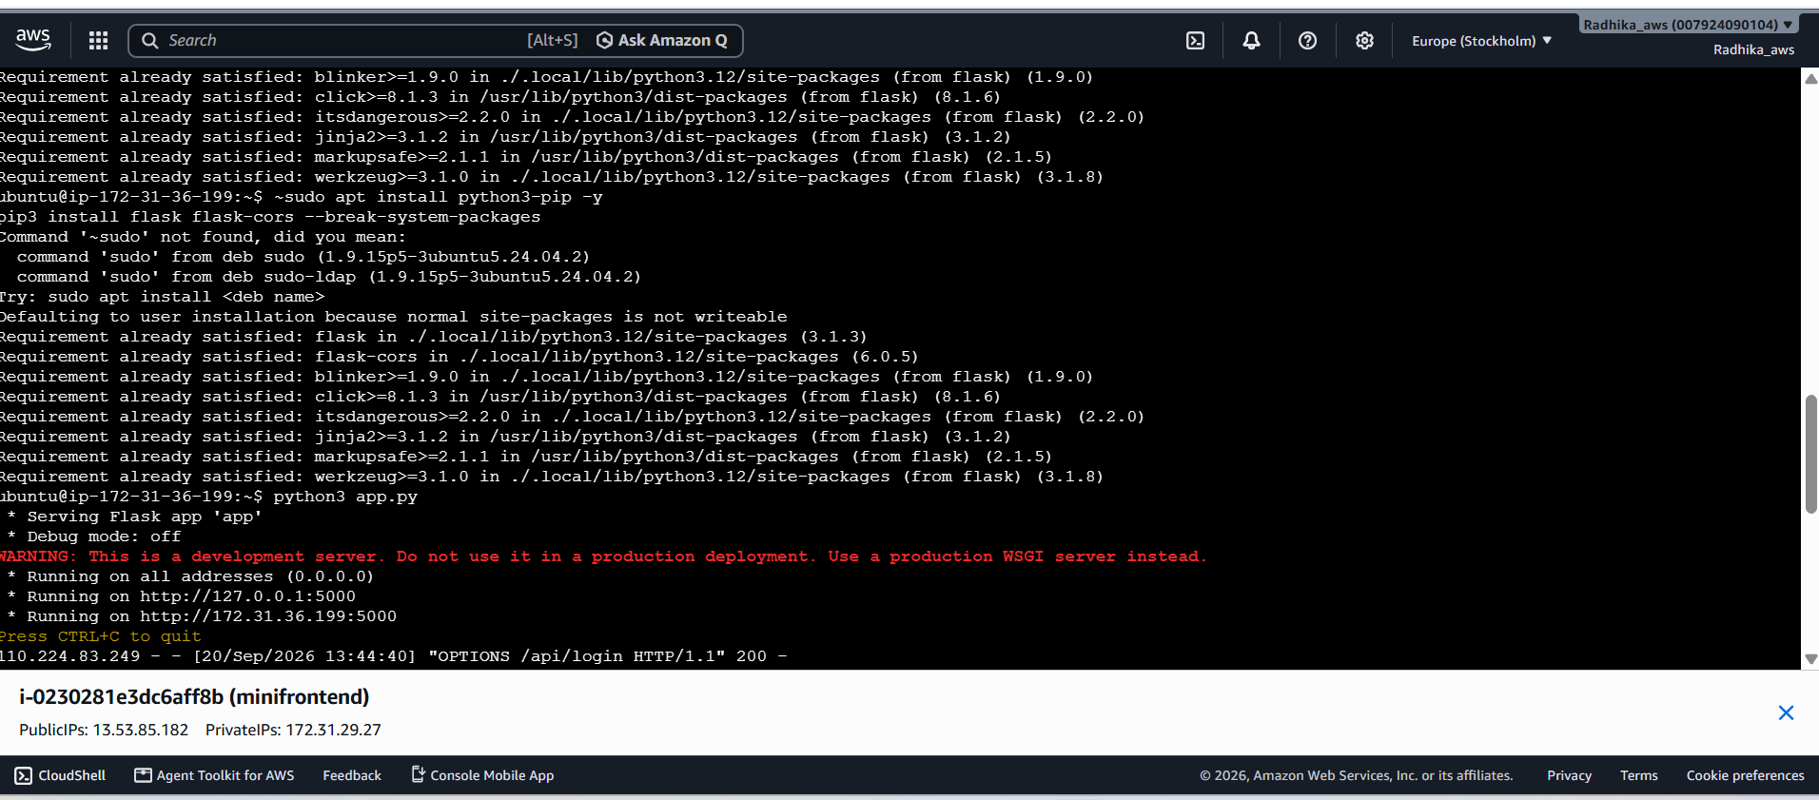
Installed packages

Testing and Final Output
After updating the backend IP address, I saved the frontend code and tested the website. I opened the frontend public IP address in the browser and clicked the LOGIN button.
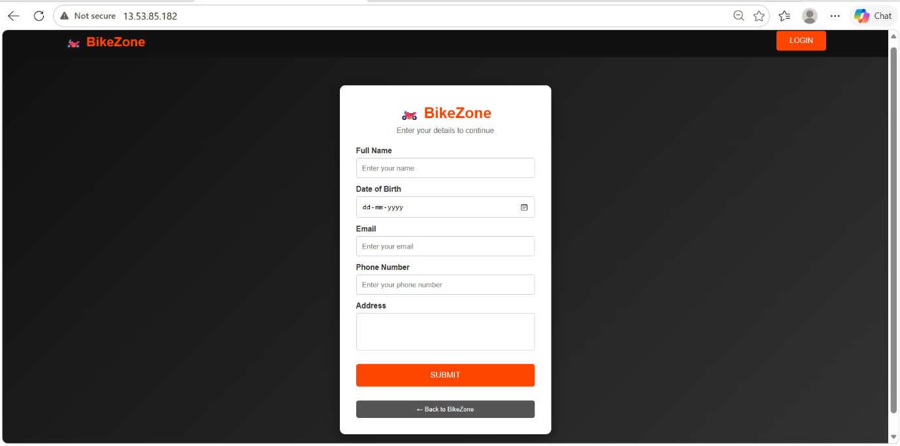
Login page

I entered the customer details such as name, date of birth, email, phone number, and address. Then, I clicked the SUBMIT button. The details were successfully sent to the backend, and the backend returned a response.
Finally, the website displayed the message "You logged in our page". This confirmed that my frontend and backend were connected successfully.
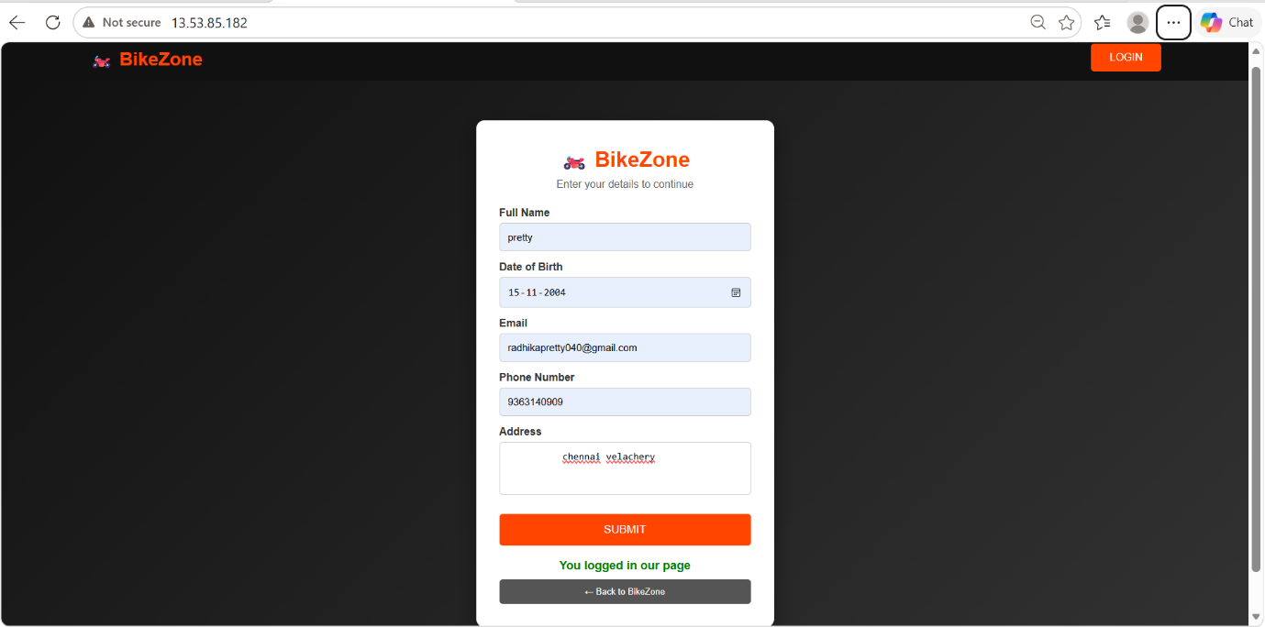
Final output with backend response

